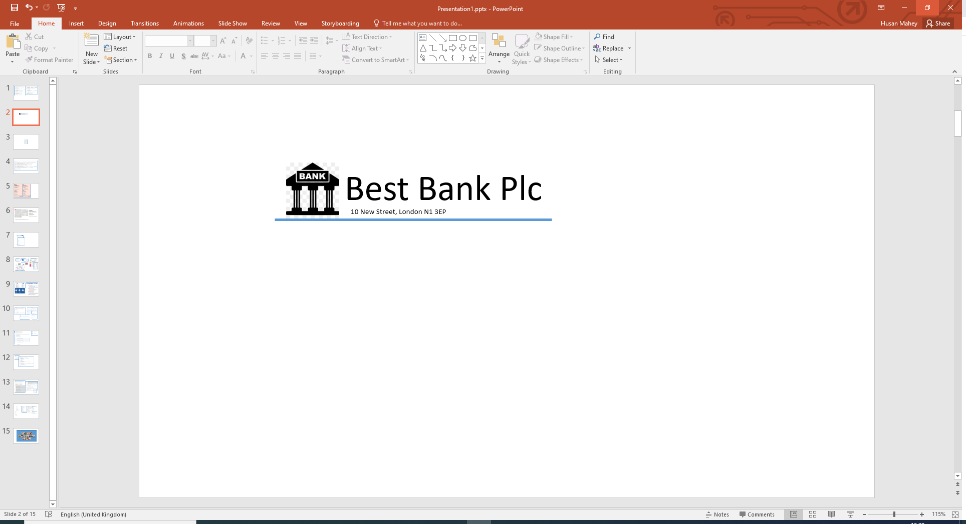

Dr David Hawkin

30 Aughton St

Norton Canes

Staffordshire

WS11 9RH

Our Ref: Q301

Dear David,

Congratulations! Based on the information provided by you, we are pleased to inform you that you have been pre-approved for your recent loan application.

**Loan Details**

Amount: £ 8,000.00

Term: 60 months

Interest Rate (APR): 3.00%

Total Payable: £ 8,616.00

Monthly Payment: £ 143.60